USER GUIDE

UPdate ERRORs

September 2018

Version 1.03

Pharmacon ITC303/309 Group

Document Revisions

|  |  |  |
| --- | --- | --- |
| Date | Version Number | Document Changes |
| 26/08/2018 | 1.01 | Initial Draft |
| 30/08/2018 | 1.02 | Draft |
| 15/09/2018 | 1.03 | Initial |
|  |  |  |
|  |  |  |
|  |  |  |
|  |  |  |
|  |  |  |
|  |  |  |

Table of Contents

1 Introduction 4

1.1 Scope and Purpose 4

1.2 Process Overview 4

2 Update an Error 5

2.1 Locate Error Record 5

2.1.1 Upload Error record to Log Error Form. 5

2.2 Update Error Details 5

2.2.1 Locate field needing amendment: 5

# Introduction

## Scope and Purpose

The purpose of this user guide is to provide instructions on how to update an error that has loaded into the Log Error Form through the search feature.

No other features of the Pharmacy Error Tracker (PET) application will be discussed in this user guide.

* To be able to use PET, the user will need basic knowledge of logging into an online application, completing an online form, and can use the search function of PET.
* This feature is only available to a user with administrator rights.
* This user guide will commence from the last step in User Guide – Search Errors.

NOTE: The user must have a legitimate reason for amending/updating an error. For example, incorrect patient details entered, incorrect patient type entered, comment missed, incorrect spelling, etc.

## Process Overview

The administrator will need to log into PET using their valid username and password.

* The Welcome Page will be presented on successful login.
* The administrator will need to follow the User Guide - Search Errors to search and load the required error into the Log Error Form.

# Update an Error

To search for an error, the user will need to launch the application, login with a valid user name and password with administration rights. Using the search bar, the user will be able locate an error or multiple errors relating to the search criteria entered. Once the error in question has been located, the administrator selects the error by clicking on the , loading the error into the Log Error form.

*NOTE: ALL fields in the form can be updated to correct information/fields that contain mistakes. Care needs to be taken to ensure correct information is not changed accidentally*.

## Locate Error Record

User must located the error record via Search Errors.

### Upload Error record to Log Error Form.

1. Select the record to be amended by clicking on the  to the right of the record.

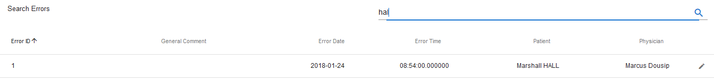

1. The record loads into the Log Error Form

## Update Error Details

### Locate field needing amendment:

1. Scroll down the form to find field containing incorrect information.
   1. If it is a list field, click on the dropdown arrow and select correct record.
   2. If it is a text field, correct mistake in the field

In the example above, the Error Type should be Dosage/Strength and the Medication Given should have been Xanax.

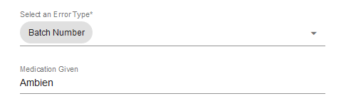

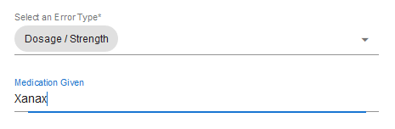

1. Select SUBMIT to update the record.



1. A successful update will receive the following message.



If you encounter issues not addressed by this user guide, please contact your account manager for additional support.